**Scripting Task**

**Task Description:**

1. Create a shell script to print the HTTP error code of guvi.in & print, the success/failure message based on the error code response.
2. Given a file, replace all occurrence of the word "give" with "learning" from 5th line till the end in only those lines that contain the word "welcome".

**Solution : 1**

**✅ Shell Script to Check HTTP Error Code of guvi.in:**

Creating a script that fetches the HTTP status code from guvi.in and prints a success or failure message based on the response.

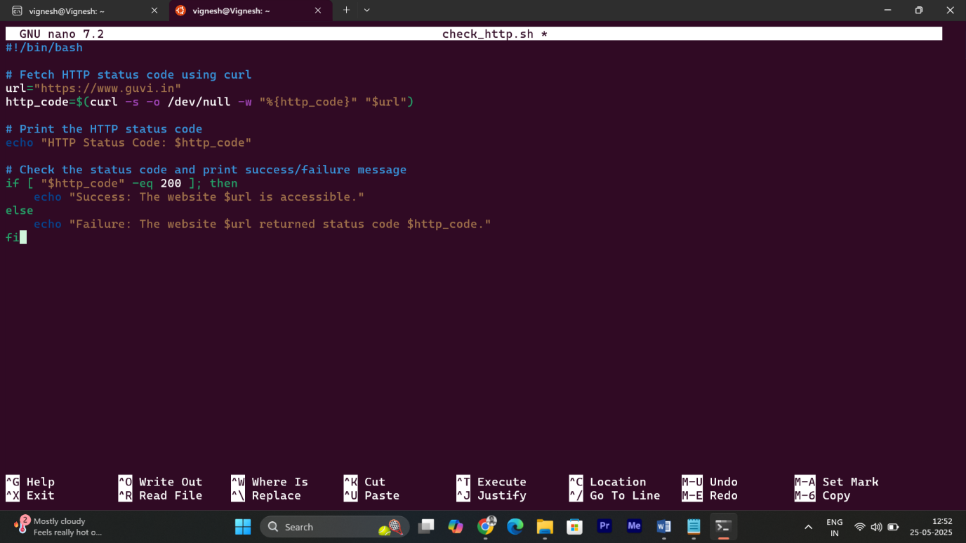

* **Shebang (#!/bin/bash):** Specifies that the script should be executed using the Bash shell.
* **URL** Definition: Sets the variable url to https://www.guvi.in.
* **curl -s**: Runs curl in silent mode to suppress progress output.
* **-o /dev/null**: Discards the response body, as we only need the status code.
* **-w "%{http_code}"**: Extracts the HTTP status code.
* The result is stored in the http_code variable.
* **Conditional Check**: If the status code is 200 (OK), it prints a **success message**.For any other status code (e.g., 404, 500), it prints a **failure message** with the code.

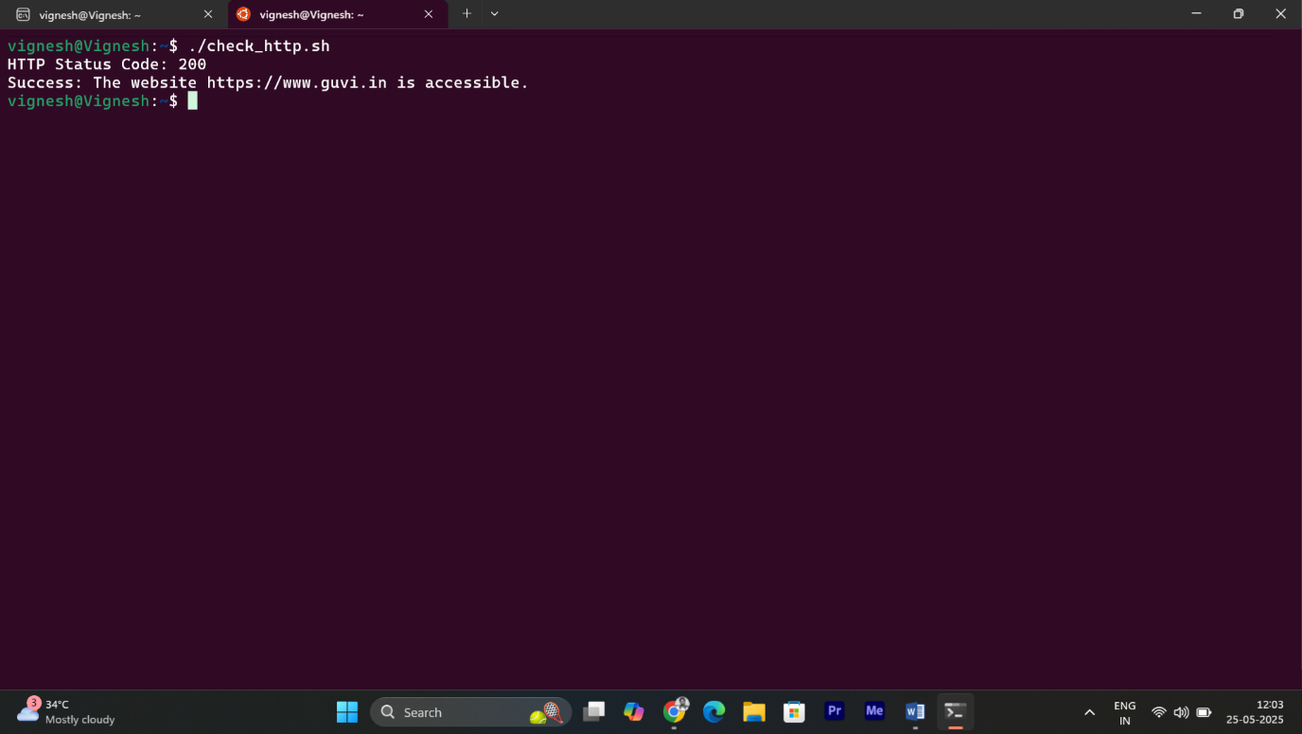

* The script assumes a 200 status code indicates success.

**Solution : 2**

**✅ Replace "give" with "learning" in Specific Lines:**

In a given file, replace all occurrences of the word "give" with "learning" from the 5th line to the end, but only in lines containing the word "welcome".

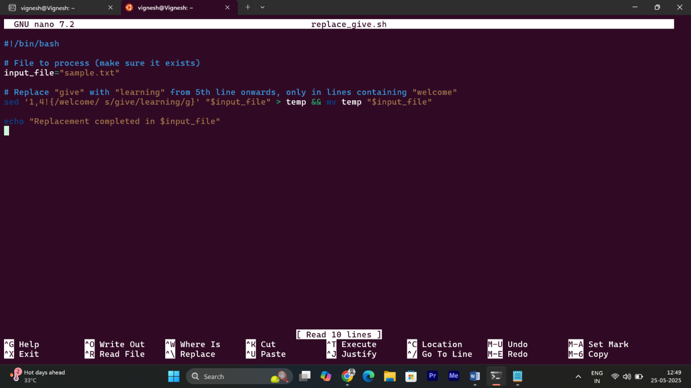

* sed is a **stream editor** used for text replacement.

**Inside the sed command:**

* **1,4!** → means: skip lines 1 to 4, and process lines from line 5 onward.
* **/welcome/** → applies the replacement only if the line contains the word "welcome".
* **s/give/learning/g** → substitute "give" with "learning" globally (in all matches on that line).
* **> temp** This saves the output to a temporary file named temp.
* **&& means:** only run the next command if the previous one succeeded.
* **mv temp "$input_file"** replaces the original file with the updated version.
* **echo** prints that the replacement is done.

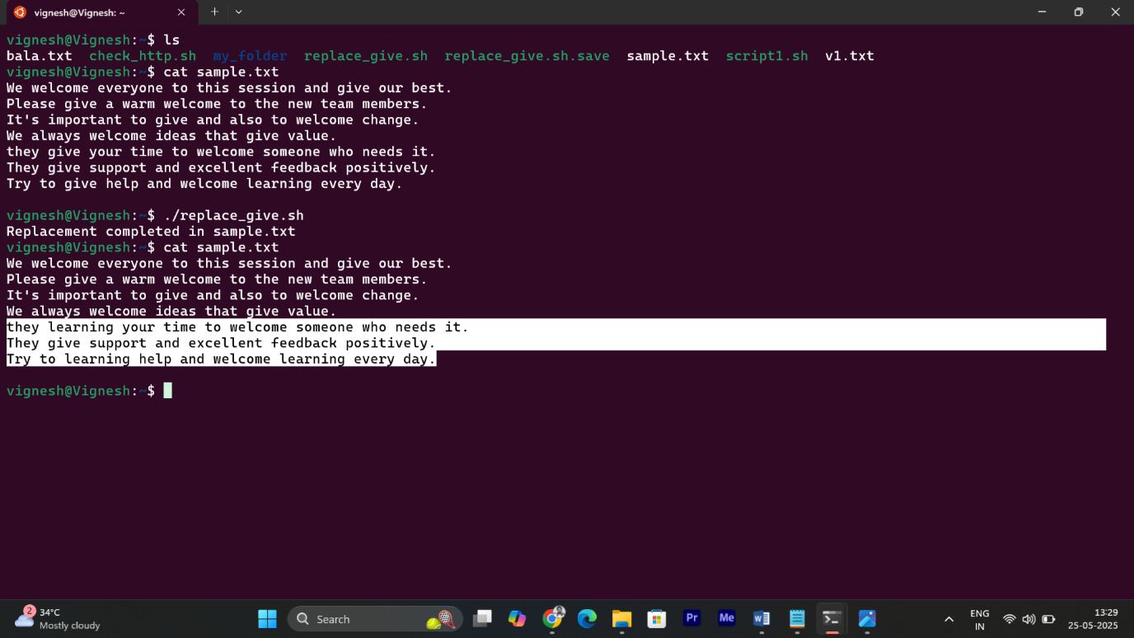

* Only lines from **line 5 onward** were **changed**, and only those that contained **"welcome".**